Calculus lab: writing lab reports using Microsoft Word

Soon you will begin writing lab and project reports using Microsoft Word, the word processor that is provided on the lab machines. You will usually want to include data, charts, and graphs from your Mathcad document. This lab will give you some practice in doing that.

NOTE: For this lab, you will need to use the completed Mathcad file FunData.mcd. Make sure that the account you are using has access to this file.

☞ Make sure that both lab partners get a chance to use the keyboard and mouse.

Click on the Start button and choose Microsoft Word (it’s probably right at the top).

Choose a font type and size that you like. I would suggest not choosing anything very unusual!

Add today’s date by choosing Insert … Date and Time.
Type your names.

A note on italics: You should always put variable names in italics. Type this sentence:

We will let the variable t stand for time, measured in seconds, and d for the distance in meters.

Almost always, if you underline something when you write it out by hand (like the title of a book, for instance), then when you use a text editor you should use italics.

Typing special symbols: Choose Insert Symbol … and choose Symbols. There you will see all sorts of unusual characters. Experiment with changing the Font and the Subset.

Type this sentence:

Mary calculated that ¾ of the candy bar would cost 49¢.

For exponents and subscripts: Look under Format … Font. Look under Effects; notice that some of your choices are superscripts (exponents) and subscripts. You can turn these effects on and off by clicking in the appropriate boxes. Type this sentence:

As everyone knows, the area of a circle with radius r is πr².

Including graphs from Mathcad

After you have done your work in Mathcad, you will want to use your results in your report. You will need to have Mathcad and Word open at the same time. Shrink the window you are typing in (click on the _ button in the upper right-hand window). Open Mathcad now, and open your completed FunData file.
Find the graph showing the population and strawberry production data. Make sure it has a title and axis labels, and looks the way you want it to look in your document. You want to copy this graph to the clipboard, but you will have to be careful: hold down the Ctrl key, then click on the graph. You should see a dotted box around the graph; at this point you can let go of the Ctrl key. (If you do not see a dotted box around the graph, it is probably because you had already selected the graph. Click on a blank area of the worksheet, then try again.)

Now choose Edit and Copy, and the graph is available on the computer’s clipboard for you, to include in another document.

Return to the original Word document (click on that option at the bottom of the screen), and Choose Edit … Paste. The graph should appear in your report.

Making tables in Word

You will probably also want to show your data in Word. It is possible to copy tables from Mathcad, but we do not want you to do this. Instead, you should enter your data in tables made by Word. To make a table, choose Table…Insert…Table. Enter the number of columns and rows you want in your table, then click Enter.

Make the table below in your document:

Time (hrs) | 0 | 1 | 2 | 3 | 4 | 5
Distance (mi) | 0 | 12.6 | 37.9 | 55.2 | 89.0 | 116.2

To alter the look or formatting of your table, open the Tables and Borders toolbar by choosing View…Toolbars…Tables and Borders. Play around with this toolbar to make your table look nice.

Using the Equation Editor in Word

To get to the equation editor, choose Insert … Object … Microsoft Equation 3.0. You should see a tool bar like this:

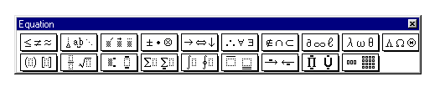
(If you don’t, choose View… Toolbar.)

Each of those buttons is actually a pull-down menu; click on each one to see what symbols are available. If you place the arrow over a symbol, and hold down the left mouse button without lifting your finger off the mouse, you can see a description of that symbol on the bottom gray part of the screen. When you finish typing in an expression, just click outside the box to exit the equation editor.

- Type in this sentence:

The recursive definition of the nth Fibonacci number 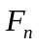 is
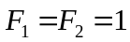
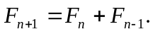

- When you want to write a fraction, think carefully about how your expression will be constructed. First tell the equation editor that you want to type in a fraction, so that it will save places for the numerator and denominator, and then fill them in.
Write

The Fibonacci numbers can be defined explicitly by

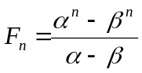
where 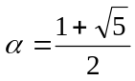 and 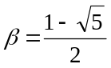.

- Type this sentence:

The derivative of a function f(t) may be computed by finding the limiting value of the difference quotient

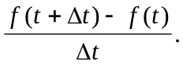

(Remember what Dr. Crannell says about placing important mathematical expressions on their own lines, and centering them, and about placing a period at the end of a sentence.)

- Sometimes you may want to include a special symbol “in-line” – as in this sentence:

We wish to find an angle whose cosine is 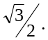

Use the Equation editor to type it.

- Sometimes you will want to include spaces in Equation Editor expressions. You can do this by finding the 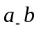symbol on the Equation Editor toolbar.

Type the following list in a single Equation Editor box, putting a space after each comma:

- Occasionally you will want to type non-italicized words within the Equation Editor, particularly if you are including units in a calculation. To do this, you will use the toolbar at the very top of the screen; from that toolbar, choose Style…Text, then type as usual (even the space bar works). When you are ready to resume typing math, choose Style…Math. Note that you should only use this for single words or short phrases; do not type entire paragraphs in Equation Editor!

Type this expression: 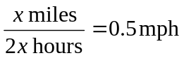

- Type these expressions:

a) 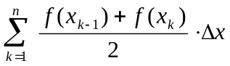 b) 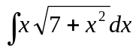
c) 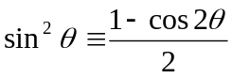 d) 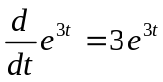

Print out your document and turn it in.

